Frank Mickan Silage and Hay Reports
With acknowledgement and appreciation to Mr Frank Mickan (Pasture and Fodder Conservation Specialist), AFIA is pleased to make available a range of silage and hay reports from Frank’s extensive work in these areas over many years.
We have attempted to categorize Frank’s reports into thirteen (13) classifications, as per the list below but this is subjective and we recommend you review the report titles contained within each classification in order to determine what report you are seeking (the reports titles are listed below under each of the thirteen classifications).
Copies of reports can then be requested via emailing AFIA (info@afia.org.au) and stating the report title that you are seeking to obtain a copy of. Reports can either be emailed or obtained in hard copy form via the post.
Copies of reports will be made available free-of-charge to all AFIA members. Non AFIA members can also request copies of reports but a small administrative fee will apply of $5 (inc. GST) per report for hard copies.
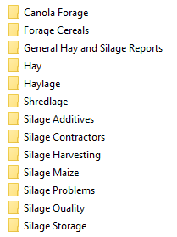
Canola Forage Reports (1 Report)

Forage Cereals (7 Reports)
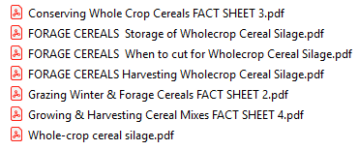

General Hay and Silage Reports (8 Reports)
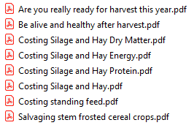
Hay (21 Reports)
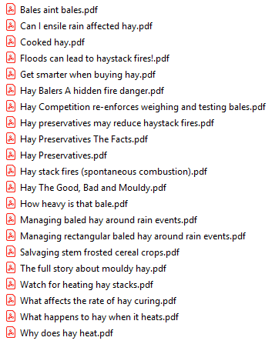
Haylage (2 Reports)
Shredlage (1 Report)

Silage Additives (7 Reports)
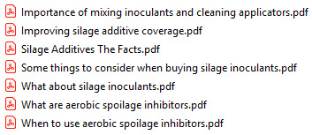
Silage Contractors (2 Reports)
Silage Harvesting (20 Reports)
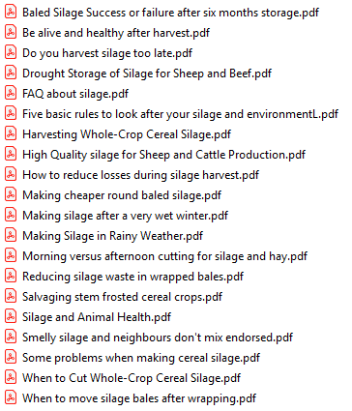
Silage Maize (1 Report)

Silage Problems (5 Reports)
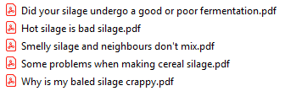
Silage Quality (13 Reports)
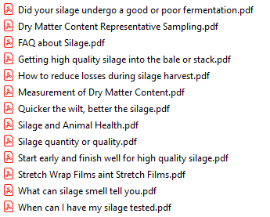
Silage Storage (10 Reports)
