our farm our plan
Online
Participant Online Course Guide

Contents
Our Farm Our Plan Online 3
Learnings for Participants 4
Activities to be Completed 5
Online Workshop 1: Why Plan? 8
Online Workshop 2: Your ‘Now’ 11
Online Workshop 3: Your ‘Where’ - Vision 14
Online Workshop 4: Your ‘Where’ – goal setting 17
Online Workshop 5: Your ‘How’ – planning for uncertainty 20
Online Workshop 6: Your plan on a page 23

Our Farm Our Plan Online

Our Farm Our Plan Online is a fully supported online learning experience, that aims to assist dairy farmers to develop a clear understanding of their business and personal goals and to get it down on paper.

You will be supported by a Regional Extension Officer who will be your key contact, and the program will be delivered by experienced dairy industry facilitators.

Resources
The program uses four key tools to turn ideas into plans, and then turn plans into the actions needed to achieve longer term goals  - Farm Fitness Checklist  - Quickplan  - Risk Register  - Plan on a Page  These are found in the Our Farm Our Plan folder that will be provided. | 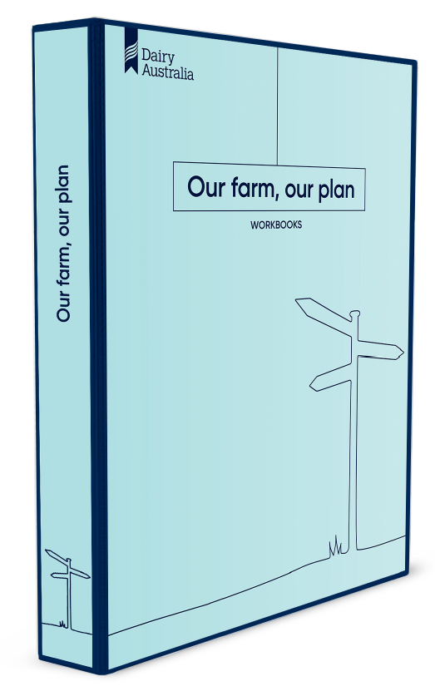
Online workshops

The program is delivered using a blended approach of online content and facilitated Zoom workshops for groups of farmers. Dairy Australia uses Zoom to conduct online workshops, meetings and events.
Your Regional Extension Officer will provide you with a link to access the Zoom sessions. You will also be fully supported to use Zoom to participate in the group workshops as part of Our Farm Our Plan.
We are using Zoom for one-on-one sessions with farmers when required.
The feedback from farmers who have participated in virtual discussion groups and online training has been very positive.
ENLIGHT

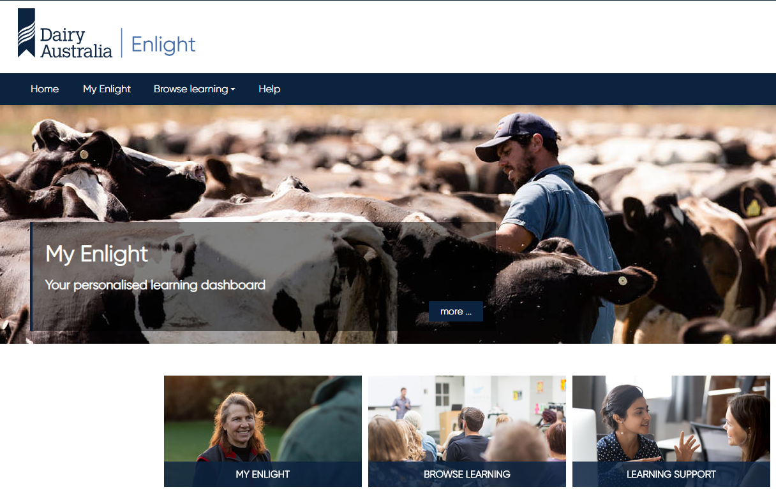 | The online content is accessed on Enlight, Dairy Australia’s online learning space.  Enlight can be accessed via the internet at https://enlight.dairyaustralia.com.au/  You will be registered and provided with a log in details by your Regional Extension Officer. Once you have logged into Enlight for the first time it is very easy and will provide you access to all programs that you are participating in.

One-on-one support

You will also have four one-to-one sessions over 24 months with an experienced person who will assist with the process of developing and implementing your plan.  In the first instance there will be two sessions as part of Our Farm Our Plan online – one between Modules 5 and 6, and another one following Module 6. | 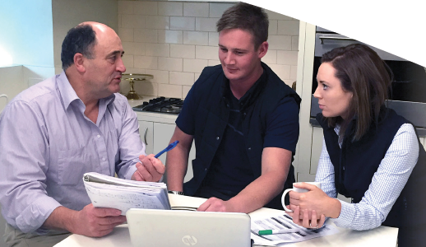

Learnings for Participants
At the end of this program, you be able to:
- Describe a vision for the future of your farm business.
- Assess your farm business’ current position.
- Conduct a SWOT analysis to identify the current strengths and weaknesses of the farm business as well as opportunities and threats.
- Identify and express goals for your farm business.
- Formulate an action plan to achieve those goals.
- Complete a risk register and develop mitigation strategies.
- Document your Plan on a Page

WORKING ONLINE

Our Farm Our Plan starts with a Zoom ‘onboarding session’ to allow you to meet the group, get everyone used to meeting online, discuss what’s coming up and to introduce you to Enlight.
To achieve the above learnings, you will complete six independent online learning modules, take part in six online group workshop sessions and two 1:1 sessions. Below outlines the activities and when they occur.

Activities to be Completed
Online Module 1: Why plan? | Timelines: Each online module should be completed before attending the online workshop session.  Each module will take between 30 and 120 minutes to complete.  They are designed to be able to be completed as smaller chunks over a couple of days, or the entire module at once to fit around your busy life.
Online Module 2: Your ‘Now’
Online Module 3: Your ‘where’ – Vision
Online Module 4: Your ‘where’ – Goal setting
Online Module 5: Your ‘how’ – planning for uncertainty
Online Module 6: Your plan on a page
Online Workshops  These will use Zoom and will typically be held a week apart allowing you time to complete the online module tasks.  The online facilitated workshop will help to support you through activities and to provide an opportunity to share with others completing the program.  A link to your Zoom workshops will be provided by your Regional Extension Officer key contact. | Time for completion: Each online workshop will be approximately 60min in duration and scheduled once.  There will be the opportunity for you to stay on at the end each workshop to discuss any aspect of the program, if you wish.
1:1 sessions  As a part of the Our Farm Our Plan online program you will have two 1:1 sessions with a facilitator.  The first will in between Module 5&6 and the second after Module 6.  You will have three further 1:1 sessions over 24 months to provide follow up support to use your plan. | These sessions will be held via Zoom conference.  The aim of the 1:1 sessions will be to provide individual support to your business while you are developing your plan (1st session) and then to complete the Plan on a Page (2nd session)

Timing of Activities to be Completed

Week | Activities | Time
0 | Onboarding workshop | 60 mins
1 | Online module: Intro and Why Plan?  Online workshop 1: Intro and overview | 30min  60-75 min
2 | Online module: Your ‘NOW’  Online workshop 2: Your ‘Now’: | 45min  60-75 min
3 | Online module: Your ‘WHERE’ - Vision  Online workshop 3: | 45min  60- 75 min
4 | Online module: Your ‘WHERE’ Goal setting  Online workshop 4: | 45 min  60-75 min
5 | Online module: Your ‘HOW’ – planning for uncertainty and risk  Online workshop 5:  1:1 session – support to develop your plan | 45-60 mins  60-75 mins  45-60 mins
6 | Online module: Your Plan on a Page  Online workshop 6: | 60-120 mins  75 mins
Post workshop 6 | 1:1 session – support to finalise your Plan | 60 - 120 mins  (cap 180 mins)

The online workshop sessions are normally at a scheduled time each week over the duration of the course. You will be provided with the information you need about this by the course facilitator.
Also, the times are published on your Enlight site. The link to access each online workshop is also published in Enlight, in the online workshop tile and in the discussion forum weekly – so the information is automatically emailed to all participants.
The people delivering the course to your group will support everyone with the technical aspects of learning, while the Regional Extension Officer will also be the key contact point for you and will support you if you have any issues with accessing the links to the workshops.
Enlight also has a support email address, where you can send any questions and get guidance on what to do: elearning.support@dairyaustralia.com.au. Enlight has a specific area on the website where everybody can find resources that help them navigate Enlight if they are having problems.

Why do the modules?
The six independent online modules provide the background information that will support the group discussion during the online workshop. Exactly when independent online modules are completed is up to each person. We do recommend they are completed at a time when other tasks are not distracting. Each module will take about 30-60 minutes to complete, depending on your level of confidence working online.
It is expected that all participants will complete all sessions and modules. If a live online workshop session needs to be missed due to personal/work circumstances, please contact your Regional Extension Officer beforehand and arrange for it to be recorded so it can be viewed before attending the next workshop.

Using this guide

A space has been provided under most tasks which you can write in to capture your responses or ideas that you draw from the online workshops.

Help using Enlight
Video guides have been created to help all participants use Enlight. These videos are accessed via YouTube.
Obtaining username and password, logging in and resetting password
https://www.youtube.com/watch?v=QTcBqhLrAUQ

Navigating Enlight
https://www.youtube.com/watch?v=0Eol7Kv0A4Q

Navigating a Course
https://www.youtube.com/watch?v=hQdflRy9dm4

Learning in Enlight
https://www.youtube.com/watch?v=UKokiiJsRAI

Communicating in Enlight
https://www.youtube.com/watch?v=qVI95B8Hmd0

Personalising Enlight and MyEnlight
https://www.youtube.com/watch?v=UTQWXu4me9g

Online Workshop 1: Why Plan?

Recommended Resources
The online modules for Our Farm Our Plan
https://enlight.dairyaustralia.com.au/
Our Farm Our Plan folder

Prior to Workshop
Prior to attending the workshop, please click on the Welcome & Where to get Help tiles on Enlight.
Also click on and complete Module 1: Why Plan?
They are located in the Our Farm Our Plan Online Program in the MyEnlight dashboard.
Be sure to have your Our Farm Our Plan folder on hand for you to access when you complete the online modules.
There are a number of short videos and online activities to be viewed or completed which will help you grasp the material being presented. This includes activities about:
- The importance of planning
- Decision making
- Your current business plan (if you have one!)
- What are you hoping to be able to do by the time you complete this program?

Overview of Workshop 1
This online workshop continues to focus on everyone getting to know each other, how to navigate Enlight and the Our Farm Our Plan course and a review of the online course. We will also touch on the concepts and material presented in the online modules.
Introductions and course overview
The facilitator will cover a few topics in this session, including:
- Using the Zoom meeting software
- Ground rules for participation online and in the program
- Brief introductions
- Overview of the program
Describe a tough decision you had to make
Thinking about a tough decision you have made in the past…the facilitator will lead the discussion about decision making including:

- What sort of information did you source to help you make that decision?

- Was there anything you wish you knew when you were making the decision?

- What was the impact of the decision? On your farm? Your family? On anything else?

Reflect on your current business plan
Your facilitator will ask you to share details of your current business plan (if you have one), or any previous experience you have. It is OK to not have any!
How do you rate yourself about having a business plan? On a scale of 0 to 5
Share your experience with business planning

How might your business benefit from an improved business plan? Why write it down.

Program reflection
Your facilitator will lead a discussion, helping you reflect on what you are hoping to achieve from the program.
What is one thing you would like to be able to do by the time you have completed the OFOP?

Online Workshop 2: Your ‘Now’

Recommended Resources
The online modules for Our Farm Our Plan
Your Our Farm Our Plan folder – the Farm Fitness Checklist workbook
https://enlight.dairyaustralia.com.au/
Dairy Australia Website

Prior to Workshop
Prior to attending the workshop, please complete the Enlight Module: Your ‘now’ located in the Our Farm Our Plan Online Program in the MyEnlight dashboard.
There are a number of online activities to be completed which will help you grasp the material being presented. This includes activities about:
- The concept of business performance
- Completing a Farm Fitness Checklist to assess your farm business’s current performance
- Conducting a situational analysis of your farm using the SWOT method.

It is also recommended that you have your Farm Fitness Checklist and your updated SWOT analysis to review during the workshop.

Overview of Session
This online workshop focusses on the importance of assessing your farm business’ current position. The purpose of the session is to consolidate and expand on concepts and material presented in the online course. You will have the opportunity to ask questions as well as work through some of the material presented in the online course.
Introduction
The facilitator will lead the discussion and outline the workshop content. They will also discuss the importance of the ‘Now’ position on the Business Planning Cycle diagram:
- How did you progress with the tasks outlined in Module 2? Farm Fitness Check list and SWOT analysis

Farm Fitness Checklist
Your facilitator will revise and expand on some of the key points of the Farm Fitness Checklist and will ask some questions to the group including:
- When completing the Farm Fitness Check list – what surprised you? Concerned you or reassured you?

- From the list, what have you nailed? What are you good at?

- What is an area you need to do?

- For those who did this with their partner, were there any surprises?

Review of your business SWOT
Your facilitator will ask you to move into break out groups. During these sessions the facilitator will ask you to share your SWOT analysis with others in the breakout room. This is a chance for you to share your thoughts, ask others for input and give others your ideas or suggestions
Write your notes here:

Your facilitator will then bring you back to the main group. Each group will be asked to share some of the things discussed in the breakout rooms.
Write your notes here:

Online Workshop 3: Your ‘Where’ - Vision

Recommended Resources
The online modules for Our Farm Our Plan.
Your Our Farm Our Plan folder – the QuickPlan workbook
https://enlight.dairyaustralia.com.au/

Prior to Workshop
Prior to attending the workshop, please complete the Enlight Module 3: Your ‘Where’ - Vision, located in the Our Farm Our Plan Online Program in the MyEnlight dashboard.
There are a number of online activities to be completed which will help you grasp the material being presented. This includes activities about:
- Expressing a vision for your farm and your life
- Sharing your vision with others in the business or key business partners

Overview of Session
This online workshop focusses on starting to develop a vision for your business and yourself. The purpose of the session is to consolidate and expand on concepts and material presented in the online course. You will have the opportunity to ask questions throughout the session.
Intro
Your facilitator will revise and expand on some of the key principles raised in the online course about the importance of a vision.
You can then contribute to the topic by participating in the discussion, which will be based around these questions:
- What is the importance of having a vision?

- Why should we write it down, say it out loud?

- Why should we share it? And provide some examples of who you might share it with

Sharing your vision
The Vision exercise that you would have completed during the online module, will be discussed during this session. You may be asked to share yours, or you may be asked to discuss the process you went through. Others in the program may also request your input to their vision. For larger groups, this task may be done in smaller break out rooms.
During this session you may be asked to share your picture and describe your vision.
What is your vision statement? If you don’t have one yet, there will be an opportunity to discuss with the group and get some ideas.

Some reflection questions that the facilitator may ask, include:
- How did you go creating your vision picture? Was it hard? Was it easy?

- How did you go creating your written vision statement for your business? What did you find enjoyable? What did you find challenging?

- Did you work with others in the business / family to gain their input? If so, how did this go?

- Do you need to do more work on this? If so, what will you do?

- Who will you share your vision with from outside your business? Why? When?

Online Workshop 4: Your ‘Where’ – goal setting

Recommended Resources
The online modules for Our Farm Our Plan.
Your Our Farm Our Plan folder – the QuickPlan workbook
https://enlight.dairyaustralia.com.au/

Prior to Workshop
Prior to attending the workshop, please complete the Enlight Module 4: Your ‘Where’ – Goal setting, located in the Our Farm Our Plan Online Program in the MyEnlight dashboard.
There are a number of online activities to be completed which will help you grasp the material being presented. This includes activities about:
- Identifying goals that you have for your farm business and the actions required
- Making sure the goals are SMART

Overview of Session
This online workshop focusses on continuing to develop a vision for your business and yourself with a greater focus on goal setting and actions. The purpose of the session is to consolidate and expand on concepts and material presented in the online course. You will have the opportunity to ask questions throughout the session.

Intro
Your facilitator will revise and expand on some of the key principles raised in the online course about the importance of goal setting, SMART goals and how to get things started.
You can then contribute to the topic by participating in the discussion, which will be based around these questions:
- How can goals contribute to the success of a business?

- Thinking about the TedTalk video, how will you achieve your most ambitious goal?

Tower of resilience
You will watch a 4-minute video. Then the facilitator will open the discussion including the following questions:
- What is resilience to you?

- If the tower is out of balance, what could happen?

- How does the Resilience Tower relate to your business? How does it relate to your goal setting and your plan?

SMART Goals
As part of the online module, you were asked to create some SMART goals for your business. During this session you will be asked to break into small groups for 10 minutes to share and discuss some of your goals.
Some reflection questions:
- Identify and share one of your goals? Is it SMART? If not, why not? Can you make it SMART?

- Discuss in your group who you might share your goals with. How will you do this and in what situation?

Sharing with the group
Following the breakout session, you will be asked to share some of your discussions with the broader group. Each person group / pair will be asked to share one goal with the wider group.
You may be asked to discuss how you made the goal SMART. Did you find this challenging? Why?
Wrap up session
During this session the facilitator will outline what is coming up in the next module and the next workshop.

Online Workshop 5: Your ‘How’ – planning for uncertainty

Recommended Resources
The online modules for Our Farm Our Plan.
Your Our Farm Our Plan folder – the Risk Register and QuickPlan workbook pages 8 – 9.
https://enlight.dairyaustralia.com.au/

Prior to Workshop
Prior to attending the workshop, please complete the Enlight Module 5: Your ‘how’ – Planning for Uncertainty, located in the Our Farm Our Plan Online Program in the MyEnlight dashboard.
There are a number of online activities to be completed which will help you grasp the material being presented. This includes activities about:
- Understanding of how the ideas of risk and risk management relate to dairy farming
- An understanding of how you approach risk
- Conducting a risk analysis for your farm business

Overview of Session
This online workshop focusses on developing an understanding of risk as it relates to dairy farming and to your business. The purpose of the session is to consolidate and expand on concepts and material presented in the online course. You will have the opportunity to ask questions throughout the session.

Intro
Your facilitator will revise and expand on some of the key principles raised in the online course about planning for uncertainty and risk.
You can then contribute to the topic by participating in the discussion, which will be based around these questions:
- Do you think dairy farming is a risky business? Why? Why not? What types of businesses do you think are risky? Why?

Understanding your attitude to risk – Deal or No Deal
The facilitator will run through a game that will help you to compare your attitude towards risk with others.
Discussion after the game may include:
- What is your attitude towards risk? How does that compare with others in your business?

Risk register
The facilitator will run through session on the risk register that you were asked to complete during the online module.
Discussion will include the following questions:
- Please describe / share one key risk from your risk register.

- What mitigations are in place? If none, what do you plan to do?

- How does this link to your ability to achieve your vision and goals?

Dairy Australia has an online library of YouTube videos which can help you to address many of your areas of risk. The facilitator will discuss this website with you.

Wrap up – What’s next?
A short session outlining what is happening in the next module and a summary of the final modules. Plus, an outline of the 1:1 session – their purpose and process.

Online Workshop 6: Your plan on a page

Recommended Resources
The online modules for Our Farm Our Plan.
Your Our Farm Our Plan folder – the Plan on a Page and QuickPlan workbook pages 26 - 27
https://enlight.dairyaustralia.com.au/

Prior to Workshop
Prior to attending the workshop, please complete the Enlight Module 6: Your Plan on a page, located in the Our Farm Our Plan Online Program in the MyEnlight dashboard.
There are a number of online activities to be completed which will help you grasp the material being presented. This includes activities about:
- Identify areas of your farm business that you want to focus on
- Document your vision, SMART goals and actions in a Plan on a Page format
- Communicate your Plan on a Page to stakeholders in your farm business

Overview of Session
This online workshop focusses on supporting you to get your Plan on a Page. The purpose of the session is to consolidate and expand on concepts and material presented in the online course. You will have the opportunity to ask questions throughout the session.

Intro
Your facilitator will revise and expand on some of the key principles raised in the online course about developing your Plan on a Page.
You can then contribute to the topic by participating in the discussion and providing feedback on how you are progressing with your plan on a page. This task will be based around these questions:
- How are you progressing with your plan on a page?

- How are you going prioritising your focus areas? Explain

Break out rooms – discussion of progress with plans
Depending on the group size, you may be asked to head into breakout rooms to discuss issues with your plan progression and discuss options to deal with these issues with other participants. Discussion questions in the breakout rooms may include:
- How are you progressing? What is working well? What is challenging?

- What are some of the things you still need to do? Make a list and discuss with the group

- What would you like some extra support with? This may include something to discuss in the 1:1 session.

Back in the main group you may be asked to share some of the discussion from the breakout room. Your facilitator will advise.
Notes:

Review of your Plan
This session refers to page 28 – 29 in in your QuickPlan workbook.
The facilitator will run through session some information regarding the best way to review your plan (once it is completed and in use).
Discussion will include the following questions:
- How often will you review your plan?
- Who will be involved?
- How long will it take?
- When will you do this – what time of year? Where will you do this?
- What info will you need?
- When will you do this next?
Notes:

Reflection
This session is a reflection on the program – and what you have achieved and learnt during the past few weeks. The facilitator will ask you to think about these things and share with the group
- Compared to when you started the course, what have you achieved?
Thinking about:
Farm Fitness Checklist, Your Vision, QuickPlan, SMART Goals, SWOT, Risk analysis
Notes:

- What do you think will be a challenge?

- What are you looking forward to with implementing your plan?

