Milking and mastitis Management
On-farm Coaching Participant Guide

Contents
Overview of the On-farm Coaching 3
SESSION 1: BRINGING IN THE COWS 5
SESSION 2: POST MILKING TEAT DISINFECTION 6
SESSION 3: CUPS OFF 7
SESSION 4: CUPS ON 8
SESSION 5: DETECTING CLINICAL MASTITIS 9
MILKING AND MASTITIS MANAGEMENT SKILLS CHECK 11

Overview of the On-farm Coaching

Dairy Australia’s Milking and Mastitis Management program has two components which include:
- Online sessions to be completed independently
- On-farm tasks to be completed under the guidance of an on-farm coach so you can apply what you’ve learnt online

Each online session MUST be completed before undertaking the on-farm coaching activities.

This will ensure you have learnt and understand the theory before your on-farm coach demonstrates the skill and supports you to practice it on-farm. This is very important for your safety and to ensure there is safe and effective milking occurring on-farm each day.

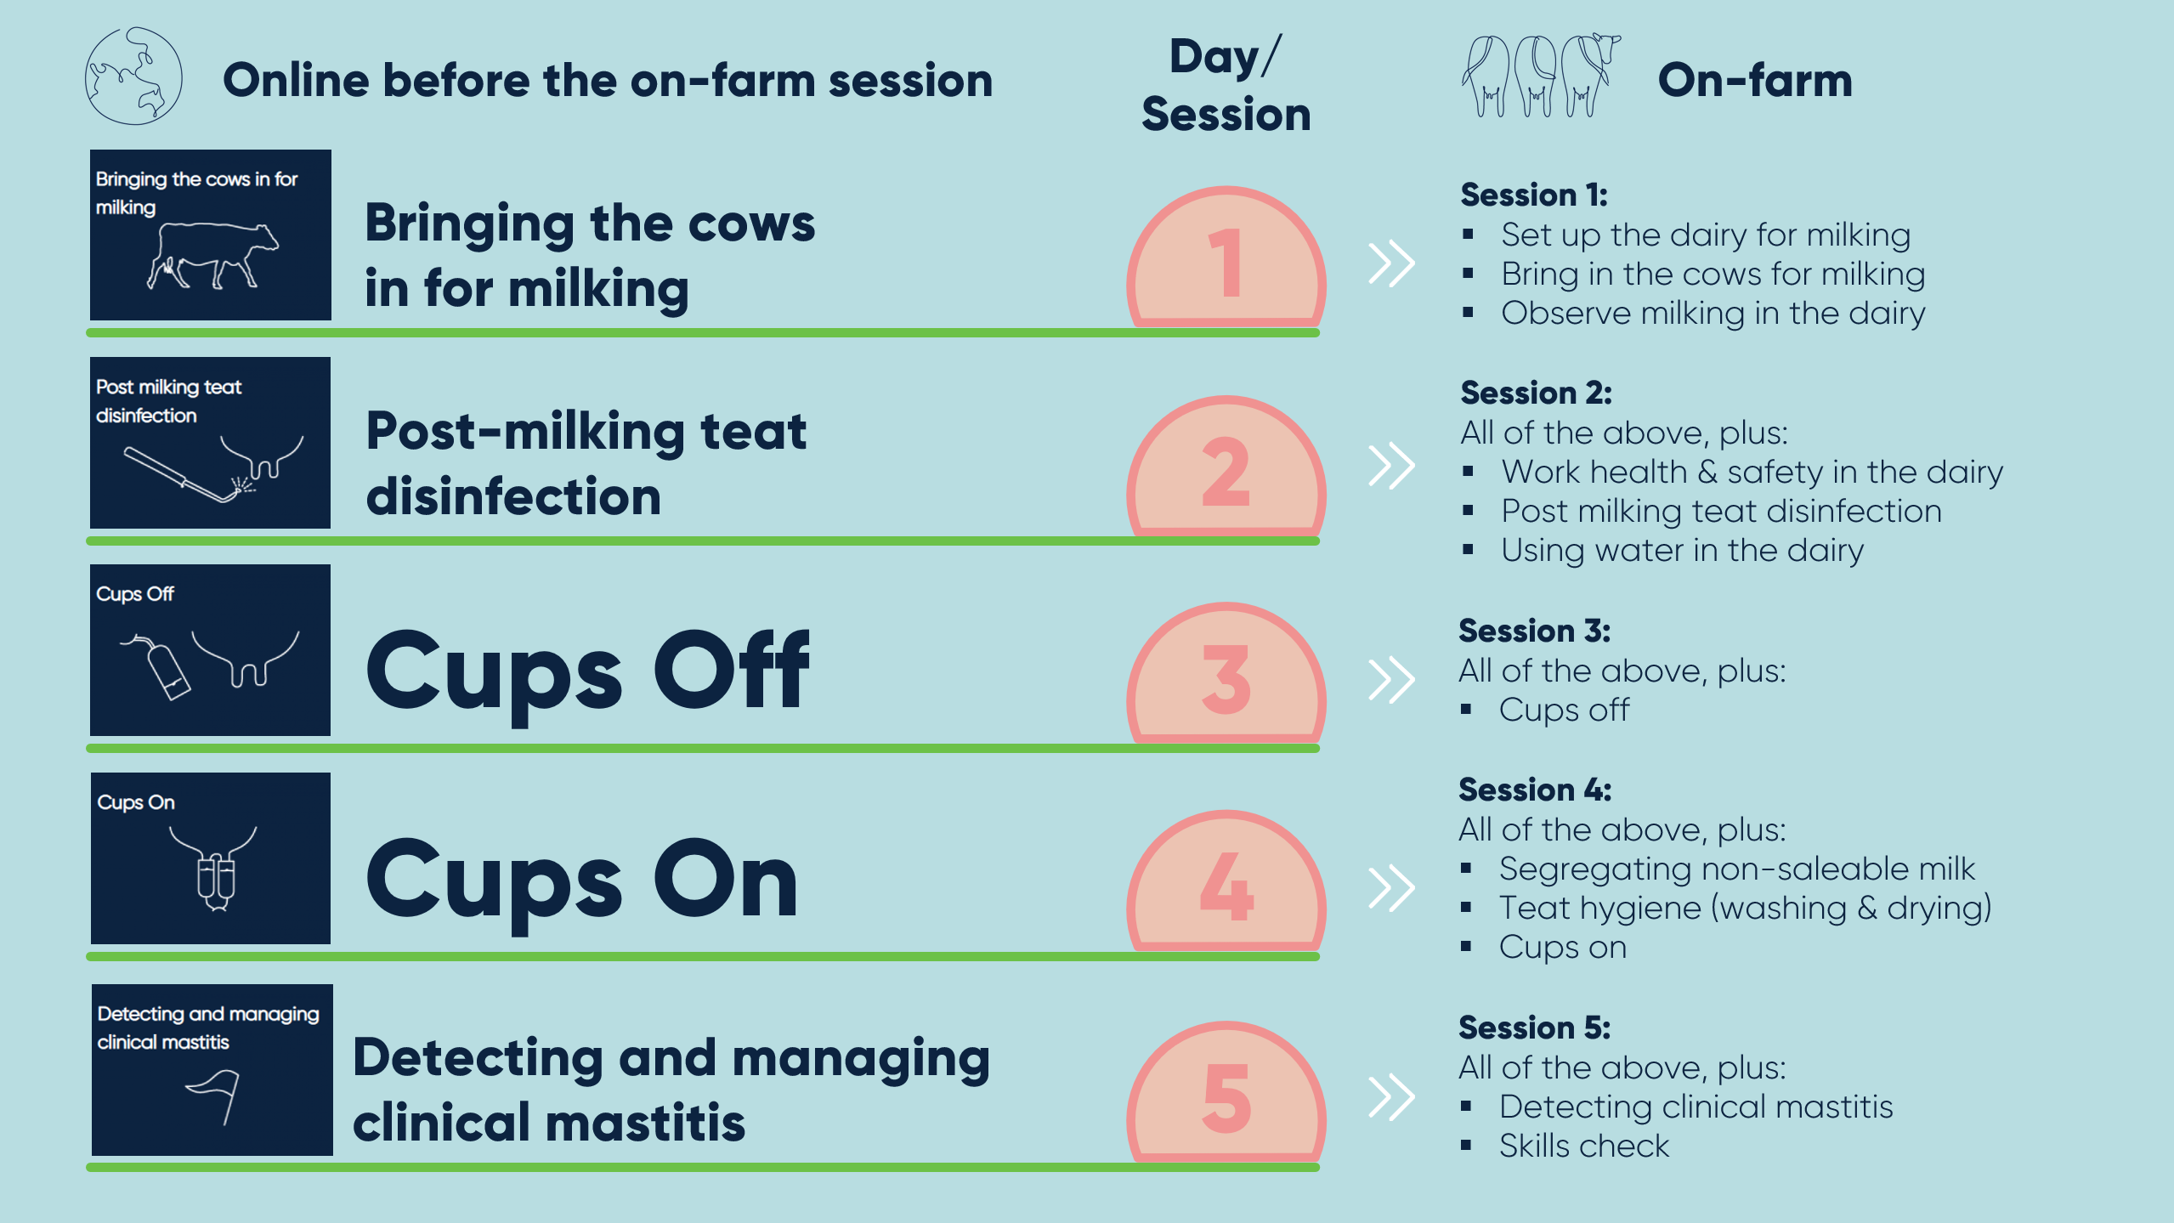

The on-farm coaching is broken up over at least five sessions. Dairy Australia recommends that these sessions occur over five days, with two milking sessions per day. This will allow time to learn the skills and then practice those skills for another milking before moving on to the next skills for learning.

However, everybody learns at a different rate and every farm has different approaches to milking. Your coach will tell you what the plan is. If you are unclear, ask your coach when you need to complete each online module.

Who is the on-farm coach and what do they do?
The on-farm coach is the person who is going to support you to learn the practical skills of milking and mastitis management. Through coaching activities each milking session, the on-farm coach will help you to apply what you have learnt online according to the policies and standard operating procedures of the farm you work on.
The on-farm coach can be an employee’s manager, supervisor, employer or another experienced member of staff. The person is determined by the dairy farm manager/owner.
Before you commence the program, please make sure you know who your on-farm coach is. If you have not met the person already, ask your supervisor to introduce you before the program begins.

Things you can do to make the most of your coaching
To help your coach help you to learn milking and mastitis management, you can do the following things:
- COMPLETE ONLINE LEARNING: Make sure you complete every online module before the next coaching session

- ASK QUESTIONS: Ask your coach questions about the module and about how your dairy farm works – make sure everything is clear to you

- HOW TO LEARN: Talk to your coach about how you like to learn – watching, talking, doing or reading? This will help them to understand the best way to coach

- FOLLOW INSTRUCTIONS: Follow all instructions at all times – your coach is there to support you to work through

- FEEDBACK: Ask your coach for feedback on what you are doing well and what needs to be done better. Feedback will then help you work out how to improve.

- SAFETY: Make sure you work in a safe manner, following the Standard Operating Procedures and Policies of your dairy farm

On the following pages are session by session guides informing you of what you will learn each coaching time.
You can print the guides and take notes of things discussed during your coaching sessions (if appropriate, safe and you want to).
You can also use the guides to make notes about what you learnt during the day at the end of the day.

SESSION 1: BRINGING IN THE COWS

Instructions:
Complete “Bringing in the cows” online module on Enlight.
Print this page for use during the second on-farm coaching session – use the below to take notes on your learning and reflections as you develop your skills.
Each heading focusses on tasks and processes you will develop with your on-farm coach during the session.

Setting up the dairy for milking and keeping safe
Milking start times and how long needs to be allowed to bring the cows in
Using vehicles to bring in the cows calmly and safely
The milking process (watching the team in action)

SESSION 2: POST MILKING TEAT DISINFECTION

Instructions:
Complete “Post milking teat disinfection” online module on Enlight.
Print this page for use during the second on-farm coaching session – use the below to take notes on your learning and reflections as you develop your skills.
Each heading focusses on tasks and processes you will develop with your on-farm coach during the session.

Preparing the dairy and bringing the cows in
You will continue learning tasks from the session before, developing your skills with support and supervision from your coach. Add any additional notes here:

Work Health and Safety (WHS) in the dairy*
Post-milking teat disinfection
Appropriate water use in the dairy and around cows
* You should speak with your doctor about Q Fever vaccination if you are not vaccinated.

SESSION 3: CUPS OFF

Instructions:
Complete “Cups off” online module on Enlight.
Print this page for use during the second on-farm coaching session – use the below to take notes on your learning and reflections as you develop your skills.
Each heading focusses on tasks and processes you will develop with your on-farm coach during the session.

Preparing the dairy and bringing the cows in
You will continue learning tasks from the session before, developing your skills with support and supervision from your coach. Add any additional notes here:

How the cups work
Knowing when cups are ready to be removed
Removing the cups
Bringing it all together – cups off and post-milking teat disinfection

SESSION 4: CUPS ON

Instructions:
Complete “Cups on” online module on Enlight.
Print this page for use during the second on-farm coaching session – use the below to take notes on your learning and reflections as you develop your skills.
Each heading focusses on tasks and processes you will develop with your on-farm coach during the session.

Preparing the dairy, bringing the cows in, post-milking teat disinfection and cups off
You will continue learning tasks from the session before, developing your skills with support and supervision from your coach. Add any additional notes here:

Cow marking
Recognising agitated cows
Pre-milking teat preparation
Cups on
Cups on for marked cows

SESSION 5: DETECTING CLINICAL MASTITIS
Instructions:
Complete “Detecting clinical mastitis” online module on Enlight.
This session has two components:
- Coaching for detecting mastitis
- Milking and Mastitis Management Skills Check
For the coaching time, print this page for use during the second on-farm coaching session – use the below to take notes on your learning and reflections as you develop your skills.
Each heading focusses on tasks and processes you will develop with your on-farm coach during the session.

Milking
You will continue learning tasks from the session before across all aspects of milking, refining your skills before you complete the skills check.

Signs of clinical mastitis
Detecting clinical mastitis

Skills check:
A skills check will be completed once you have done all online modules and on-farm coaching sessions.

There are two components to the skills check:
- ONLINE: An online quiz completed through Enlight
- ON-FARM: An on-farm observation of your skills, completed by the on-farm coach

Before you do the on-farm skills check, you should complete the skills check quiz on Enlight. On successful completion of the quiz, you will receive a certificate you can provide to your employer and use in your resume. Your coach may ask you for a copy at the final coaching session.

The on-farm skills check is usually completed at the fifth on-farm coaching session, but can be done later if you require more guidance on any tasks or time to practice. You coach will tell you when the on-farm skills check will occur.

The on-farm skills check sheet completed by your on-farm coach will be handed to you after it is completed. You can then reflect on what you did well and what still needs improvement. You will be able to also use it for your resume and to show any future employers should you change jobs.

Head to the SKILLS CHECK section of Enlight for the quiz and to access the Milking and Mastitis On-farm Skills Check details.

